How Air Bags Work  ››Tell a friend about this article! |  | › Introduction to How Air Bags Work  › The Basics  › Development  › Safety  › Deactivation  › The Future of Air Bags  › Lots More Information!  › Search Google  › Shop or Compare Prices  › What do you think?
For years, the trusty seat belt provided the sole form of passive restraint in our cars. There were debates about their safety, especially relating to children, but over time, much of the country adopted mandatory seat-belt laws. Statistics have shown that the use of seat belts has saved thousands of lives that might have been lost in collisions.
Air bags have been under development for many years. The attraction of a soft pillow to land against in a crash must be very strong -- the first patent on an inflatable crash-landing device for airplanes was filed during World War II! In the 1980s, the first commercial air bags appeared in automobiles.
Since model year 1998, all new cars have been required to have air bags on both driver and passenger sides. (Light trucks came under the rule in 1999.) To date, statistics show that air bags reduce the risk of dying in a direct frontal crash by about 30 percent. Newer than steering-wheel-mounted or dashboard-mounted bags, but not so widely used, are seat-mounted and door-mounted side air bags. Some experts say that within the next few years, our cars will go from having dual air bags to having six or even eight air bags! Having evoked some of the same controversy that surrounded seat-belt use in its early years, air bags are the subject of serious government and industry research and tests.
In this edition of HowStuffWorks, you'll learn about the science behind the air bag, how the device works, what its problems are and where the technology goes from here.

The Basics
Before looking at specifics, let's review our knowledge of the laws of motion. First, we know that moving objects have momentum (the product of the mass and the velocity of an object). Unless an outside force acts on an object, the object will continue to move at its present speed and direction. Cars consist of several objects, including the vehicle itself, loose objects in the car and, of course, passengers. If these objects are not restrained, they will continue moving at whatever speed the car is traveling at, even if the car is stopped by a collision.
Stopping an object's momentum requires force acting over a period of time. When a car crashes, the force required to stop an object is very great because the car's momentum has changed instantly while the passengers' has not -- there is not much time to work with. The goal of any supplemental restraint system is to help stop the passenger while doing as little damage to him or her as possible.
What an air bag wants to do is to slow the passenger's speed to zero with little or no damage. The constraints that it has to work within are huge. The air bag has the space between the passenger and the steering wheel or dash board and a fraction of a second to work with. Even that tiny amount of space and time is valuable, however, if the system can slow the passenger evenly rather than forcing an abrupt halt to his or her motion.
There are three parts to an air bag that help to accomplish this feat:
- The bag itself is made of a thin, nylon fabric, which is folded into the steering wheel or dashboard or, more recently, the seat or door.
- The sensor is the device that tells the bag to inflate. Inflation happens when there is a collision force equal to running into a brick wall at 10 to 15 miles per hour (16 to 24 km per hour). A mechanical switch is flipped when there is a mass shift that closes an electrical contact, telling the sensors that a crash has occurred. The sensors receive information from an accelerometer built into a microchip.
- The air bag's inflation system reacts sodium azide (NaN3) with potassium nitrate (KNO3) to produce nitrogen gas. Hot blasts of the nitrogen inflate the air bag (click here for the full chemical equation).
The inflation system is not unlike a solid rocket booster (see How Rocket Engines Work for details). The air bag system ignites a solid propellant, which burns extremely rapidly to create a large volume of gas to inflate the bag. The bag then literally bursts from its storage site at up to 200 mph (322 kph) -- faster than the blink of an eye! A second later, the gas quickly dissipates through tiny holes in the bag, thus deflating the bag so you can move.
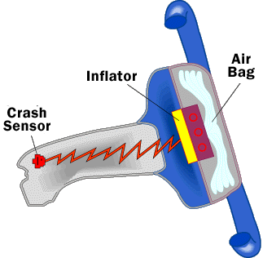

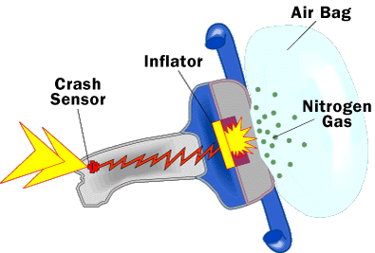

The air bag and inflation system stored in the steering wheel

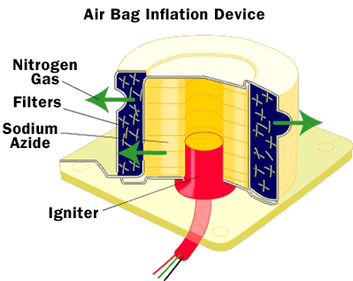
The inflation system uses a solid propellant and an igniter.
Even though the whole process happens in only one-twenty-fifth of a second, the additional time is enough to help prevent serious injury. The powdery substance released from the air bag, by the way, is regular cornstarch or talcum powder, which is used by the air bag manufacturers to keep the bags pliable and lubricated while they're in storage.

Development
According to Scientific American:
The idea of using a rapidly inflating cushion to prevent crash injuries had a long history before the U.S. Department of Transportation called for the equipment to be adapted for automobiles in the 1980s. The first patent on an inflatable crash-landing device for airplanes was filed during World War II.
Early efforts to adapt the air bag for use in cars bumped up against prohibitive prices and technical hurdles involving the storage and release of compressed gas. Researchers wondered:
- If there was enough room in a car for a gas canister
- Whether the gas would remain contained at high pressure for the life of the car
- How the bag could be made to expand quickly and reliably at a variety of operating temperatures and without emitting an ear-splitting bang
They needed a way to set off a chemical reaction that would produce the nitogen that would inflate the bag. Small solid-propellant inflators came to the rescue in the 1970s.
In the early days of auto air bags, experts cautioned that the new device was to be used in tandem with the seat belt. Seat belts were still completely necessary because air bags worked only in front-end collisions occurring at more than 10 mph (6 kph). Only seat belts could help in side swipes and crashes (although side-mounted air bags are becoming more common now), rear-end collisions and secondary impacts. Even as the technology advances, air bags still are only effective when used with a lap/shoulder seat belt!

Safety
It didn't take long to learn that the force of an air bag can hurt those who are too close to it. Researchers have determined that the risk zone for driver air bags is the first 2 to 3 inches (5 to 8 cm) of inflation. So, placing yourself 10 inches (25 cm) from your driver air bag gives you a clear margin of safety. Measure this distance from the center of the steering wheel to your breastbone. If you currently sit less than 10 inches away, you can adjust your driving position in the following ways:
- Move your seat to the rear as far as possible while still reaching the pedals comfortably.
- Slightly recline the back of your seat. Although car designs vary, most drivers can achieve the 10-inch distance even with the driver seat all the way forward by slightly reclining the back of the seat. If reclining the seat makes it hard to see the road, you can raise yourself up by using your car's seat-raising system (not all cars have this!) or a firm, non-slippery cushion to achieve the same effect.
- Point the air bag toward your chest, instead of your head and neck, by tilting your steering wheel downward (this only works if your steering wheel is adjustable).
The rules are different for children. An air bag can seriously injure or even kill an unbuckled child who is sitting too close it or is thrown toward the dash during emergency braking. Experts agree that the following safety points are important:
- Children 12 and under should ride buckled up in a properly installed, age-appropriate rear car seat.
- Infants in rear-facing child seats (under one year old and weighing less than 20 pounds / 9 kg) should never ride in the front seat of a car that has a passenger-side air bag.
- If a child over one year old must ride in the front seat with a passenger-side air bag, he or she should be in a front-facing child safety seat, a booster seat or a properly fitting lap/shoulder belt, and the seat should be moved as far back as possible.

Deactivation
In response to concerns about children -- and others, especially smaller people -- being killed or seriously injured by malfunctioning or overly powerful air bags, the National Highway Traffic Safety Administration (NHTSA) in 1997 issued a final rule to allow auto manufacturers to use lower-powered air bags. This rule permits air bags to be depowered by 20 to 35 percent. In addition, starting in 1998, repair shops and dealers were allowed to install on/off switches that allow air bags to be deactivated. Vehicle owners could now be authorized (by the NHTSA) to get on/off switches installed for one or both air bags in their car if they (or other users of their car) fell into one or more of these specific risk groups:
- For both driver and passenger sides - Individuals with medical conditions in which the risks of deploying the air bag exceed the risk of impact in the absence of an air bag
- For the driver side (in addition to medical conditions) - Those who cannot position themselves to properly operate their cars at least 10 inches (25.4 cm) back from the center of the driver air bag cover
- For the passenger side (in addition to medical conditions) - Individuals who need to transport a baby in a rear-facing child restraint in the front seat because the car has no rear seat, the rear seat is too small to accommodate a rear-facing child seat or because it's necessary to constantly monitor a child's medical condition
- For the passenger side (in addition to medical conditions) - Individuals who need to carry children between one and 12 years old in the front seat because (a) the car has no rear seat, (b) the vehicle owner must carry more children than can fit into the back seat or (c) because it's necessary to constantly monitor a child's health
If you would like to get an on-off switch installed in your car, you need a copy of NHTSA's brochure, "Air Bags and On-Off Switches: Information for an Informed Decision," and the accompanying form, Request for Air Bag On-Off Switch. You can find these on the NHTSA Web site, as well as at AAA clubs, new-car dealers and state motor vehicle departments. The NHTSA will send you a letter of authorization that you can take to a repair shop. (Before you bother with all this, you should check with your auto dealer or repair shop to see if an on-off switch is available for your car.) Some retrofit on-off switches can be found and used if federal requirements are met -- switches must be operated by a key and equipped with warning lights to indicate whether the bags are turned off or on.
Obviously, even you have the option of turning it off, the air bag should be left on for drivers who can sit at least 10 inches back. For those who can't (even with the suggestions listed above), the bag can be turned off. A group of doctors at the National Conference on Medical Indications for Air Bag Deactivation considered the medical conditions commonly reported in letters to the NHTSA as possible justification for turning off air bags. They did not, however, recommend turning off air bags for relatively common conditions, such as pacemakers, eyeglasses, angina, emphysema, asthma, mastectomy, previous back or neck surgery, advanced age, osteoporosis, arthritis or pregnancy.
Generally speaking, you can't deactivate your air bag without installing a retrofit on-off switch. However, if a retrofit on-off switch is not yet available (from the vehicle manufacturer) for your car, the NHTSA will authorize air bag deactivation on a case-by-case basis under appropriate conditions. Never try to disable the bag yourself -- remember, this is no soft cushion! It packs a wallop and can hurt you when you don't know what you're doing.
As for factory-installed on-off switches, the NHTSA allows car manufacturers to install passenger air bag on-off switches in new vehicles under limited circumstances -- only if the vehicle has no rear seat or if the rear seat is too small to accommodate a rear-facing child safety seat. And manufacturers are not currently allowed to install on-off switches for the driver air bag in any new vehicle. Why these rules? The NHTSA decided against widespread factory-installed on-off switches for fear that they would become standard equipment in all new vehicles -- even those purchased by people not in at-risk groups. They also saw the integration of on-off switches into new cars (and the subsequent redesign of instrument panels) as something that would divert resources from the development of safer, more advanced air bag systems.

The Future of Air Bags
Activities aimed at maintaining and improving the lifesaving benefits of air bags are in full swing. New NHTSA-sponsored tests use improved "dummy" injury criteria based on new knowledge and research.
Until recently, most of the strides made in auto safety were in front and rear impacts, even though 40 percent of all serious injuries from accidents are the result of side impacts, and 30 percent of all accidents are side-impact collisions. Many carmakers have responded to these statistics (and the resulting new standards) by beefing up doors, door frames and floor and roof sections. But cars that currently offer side air bags represent the new wave of occupant protection. Engineers say that designing effective side air bags is much more difficult than designing front air bags. This is because much of the energy from a front-impact collision is absorbed by the bumper, hood and engine, and it takes almost 30 to 40 milliseconds before it reaches the car's occupant. In a side impact, only a relatively thin door and a few inches separate the occupant from another vehicle. This means that door-mounted side air bags must begin deploying in a mere five or six milliseconds!
Volvo engineers experimented with different ways of mounting side air bags and chose seat-back installation because that protects passengers of all sizes regardless of how the seat is positioned. This arrangement allows them to place a triggering mechanical sensor on the sides of the seat cushions under the driver and front passenger. This prevents the air bag on the undamaged side of the car from inflating. Installing the entire air bag package in the seat-back also offers the advantage of preventing unnecessary deployments that might be caused by collisions with pedestrians or bicycles. It takes a collision of about 12 mph (19 kph) to trigger side air bags.
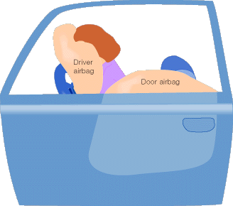
BMW engineers have chosen door-mounted air bags. The door has more space, allowing for a bigger bag that provides more coverage.
The head air bag, or Inflatable Tubular Structure (ITS), was featured in all of BMW's 1999 models (except convertibles). The head bags look a little like big sausages and, unlike other air bags, are designed to stay inflated for about five seconds to offer protection against second or third impacts. Working with the side air bag, the ITS is supposed to offer better protection in some side collisions.
All of this makes it pretty clear that the science of air bags is still new and under rapid development. You can expect many advances in this field as designers come up with new ideas and learn from real-world crash data.
For more information on air bags and related topics, check out the links on the next page.

